ISRAEL AND THE OLIVE TREE
(From the Editor of “BIWF Victoria Notes”)
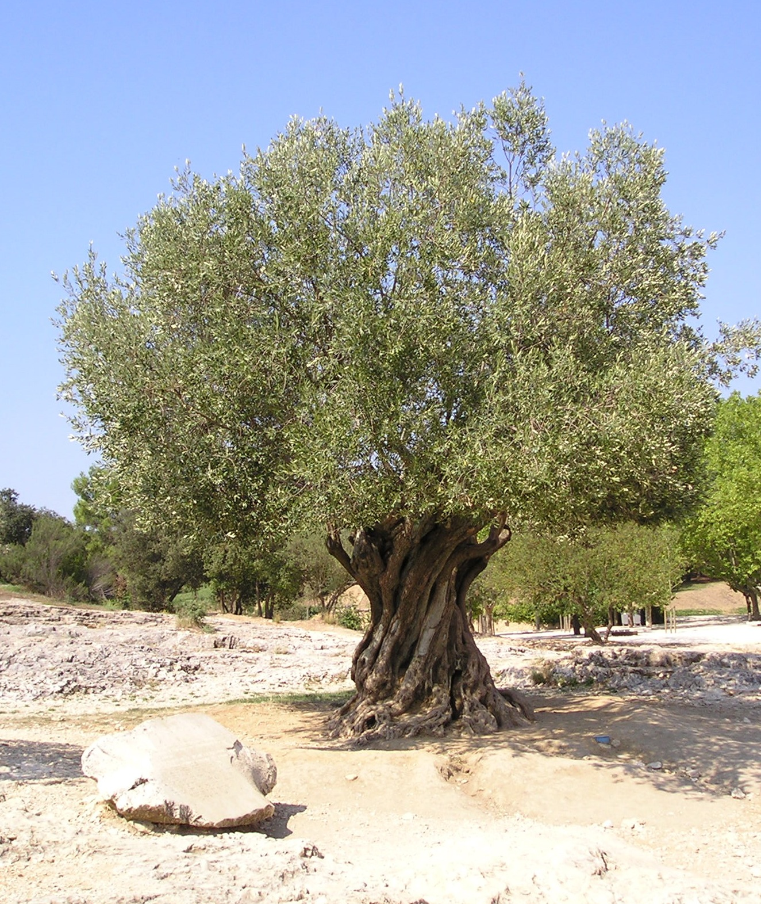
An Olive tree that is over 1000 years old.

The Olive tree has been an intriguing symbol throughout the Bible. It has been used as an emblem of peace, prosperity, wealth, beauty and dignity, fruitfulness and testimony for God. King David wrote:
But I am like a green olive tree in the house of God: I trust in the mercy of God for ever and ever. (Psa. 52:8)
Scripture refers to Jacob/Israel as an olive tree:
The LORD called thy name, A green olive tree, fair, and of goodly fruit: with the noise of a great tumult He hath kindled fire upon it, and the branches of it are broken. (Jer. 11:16)
This symbolised Israel’s fall from faith and blessing, to apostasy and punishment. But speaking of their yet future return to God in the coming Kingdom age Hosea 14:6 states: His branches shall spread, and his beauty shall be as the olive tree, and his smell as Lebanon.
The first mention of the Olive is the leaf brought back to Noah’s Ark by the dove:
And the dove came in to him [Noah] in the evening; and, 10, in her mouth was an olive leaf plucked off: so Noah knew that the waters were abated from off the earth. (Gen. 8:11)
The olive tree symbolised the spiritual prerogative which would be vested in the Israel People as the foundation for God’s Kingdom on earth, and as custodians of His Word of Truth. The olive leaf looked forward to a new beginning for the Adamic Race, and God’s great purpose to be completed, viz., the final restoration of this earth to spiritual perfection - an earth in which God’s Will will be done as it is in heaven.
Four olive trees are used as symbolic of God’s ‘anointed ones’ and His ‘witnesses’. (Zech. 4:3, 11-14; Rev. 11:3) But to be God’s witnesses was the role of the Israel People:
Ye are my witnesses, saith the LORD, and my servant whom I have chosen: (Isa. 43:10)
. . . . ye are my witnesses, saith the LORD, that I am God. (lsa.43:12)
Fear ye not, . . . .ye are even my witnesses . . . . (Isa.44:8)
The branches of the olive tree were among those used for the construction of booths in which the Israel people dwelt during the Feast of Tabernacles. This festival celebrated the blessings of the Harvest, and the Presence of the Lord God in their midst, when He dwelt in the Inner Sanctuary of the Tabernacle and later Temples. (Neh. 8:15)
The cherubim of Solomon’s Temple (c.l000 BC), and the doors and posts of the Inner and Outer Sanctuary, were made of olive-wood (1 Kings 6:23, 31-33).
Before they entered Canaan Israel were promised they would be given: . . . . vineyards and olive trees, which thou plantedst not . . . . (Deut. 6:11; 8:8; Josh. 24:13).
This was of great advantage to the young nation in occupying the Land as the olive tree is exceptionally long-lived, even over a thousand years, and can live for centuries whether cultivated or not: but it may take UP to 15 years before it is mature enough to produce a harvest.
Israel has been an enduring People for over three and a half millennia, and their history has been one of long periods of spiritual decline interspersed by periods of repentance and spiritual awakening. Their spiritual “cultivation” has been, therefore, intermittent. But the knowledge of the One True God and the understanding of His Word have been preserved by the few faithful “olives” during the times of apostasy, while in times of national repentance and religious revival the Israel Peoples have produced an abundance of “olives” (faithful servants of the Lord). This has been reflected in the life of the nation which has during such periods has been richly blessed and exhibited the fruit of righteousness, justice and mercy, equity and peace.
If an olive tree is cut down it will send up as many as five new shoots from its roots, to produce five new trunks. Aged trees also will often perpetuate themselves in this way. This is reflected in the third verse of Psalm 128:
Thy wife shall be as a fruitful vine by the sides of thine house: thy children like olive plants round about thy table.
Israel Britain has seen in her ‘old age’ the nations of the white Commonwealth grow up and mature around her as children from her own roots.

THE OLIVE AND THE PROMISED LAND
Throughout millennia the olive tree has been so abundant in Palestine that it has been considered Palestine’s characteristic tree. Olive orchards from time immemorial have provided one of the chief sources of wealth for the country’s inhabitants, and one of its three chief staple products - corn (wheat and barley), wine and oil. It is significant that the Land of Israel’s inheritance should be so marked by olive trees.
Galilee in particular abounded in olive orchards. Gischala in the north was previously known as Gushhalab (fat soil) and was famous for its oil. The abundance of oil in Galilee is illustrated by the use made of boiling oil in the defence of Jotapata when the defenders poured large quantities of oil down on the attacking Roman soldiers. Part of the Galilee area comprised the territory of the Tribe of Asher of whom the Bible says:
Let Asher be blessed with children, . . . . and let him dip his foot in oil . . . . (Deut. 33:24)
THE FLOWERS AND FRUIT
Each year the olive tree produces a great profusion of small, white flowers which are easily blown off. They are cast off by the millions like flakes of snow (Job 15:33). Less than one percent of flowers come to maturity and produce fruit. Israel has been a multitudinous People but only a relative few in any age have come to spiritual maturity and produced spiritual fruit.
The flower that does mature is followed by a smooth, oval, plum-like fruit comprising an oily pulp enclosing a hard rough stone. Only the fully ripe berries are eaten raw or preserved, but before they can be eaten they must be soaked in brine to remove a bitter substance which they contain. The brine [salt] acts as a purifying agent and is necessary even for the most perfect fruits of the harvest, reminding us that all have sinned, and come short of the glory of God; (Rom. 3:23) and can be cleansed only through faith in the Sacrifice of our Lord Jesus Christ on their behalf.
The rest of the olive crop is pressed to produce oil.
THE OIL
The olive tree in its natural, or wild state bears very few berries and these are small and without oil.
Wild olive trees growing on the hillsides were often subjected to grafting with cuttings from the cultivated, productive trees, so that they would produce good fruit. A new, or productive olive tree may be created, therefore, by grafting a productive branch from a good, cultivated tree, on to a wild olive stock.
Later, when the grafted tree has grown, if one of the large, wart-like knobs on the trunk above the graft, which contains an embryo shoot or a small branch, is cut off and carefully cultivated it will strike out roots and grow. This new plant will be a good tree from the root and all scions taken from it will be “good by nature,” bearing berries with oil.
The unripe berries are pressed to produce the oil, a good tree yielding from 10 to 15 gallons in one season. Even a tree which has been long neglected will revive again, if recultivated, and begin to yield as before. That olive oil was a great source of wealth to the Hebrews is demonstrated by the fact that King Solomon gave quantities of it annually to Hiram King of Tyre, in exchange for the services of his people in building the Temple:
And, behold, I will give to thy servants, the hewers that cut timber, twenty thousand measures of beaten wheat, and twenty thousand measures of barley, and twenty thousand baths of wine, and twentv thousand baths of oil. (2 Chron. 2:10)
As one bath contained approximately seven and a half gallons of oil, this would approximate 150,000 gallons.
Psalm 45:7 speaks of the oil of gladness [joy] and Isaiah 61:3 of the oil of joy: “Joy” is listed in Galatians 5:22-23, as being part of the “fruit of the Spirit”.
But the fruit of the Spirit is love, joy, peace, longsuffering, gentleness, goodness, faith, meekness [patience], temperance . . . .
The oil of the olive tree, therefore, symbolises the “fruit of the Spirit,” which is the evidence of the activity of the indwelling Holy Spirit in our lives. As fruit is produced and becomes obvious, it is seen and experienced by others, just as the presence of oil in a lamp is made obvious by the light of its burning. Our lives as individual believers are judged by the abundance, or otherwise, of the above “fruit” - not by wealth, or popularity, or influence, or any other of man’s valued achievements.
When national Israel, repentant, returned, and restored, is given a “heart of flesh” in place of their “heart of stone,” they will bring forth, nationally, the “fruit of the Spirit.”

For I will take you from among the heathen, and gather you out of all countries, and will bring you into your own land.
Then will I sprinkle clean water upon you, and ye shall be clean: from all your filthiness, and from all your idols, will I cleanse you.
A new heart also will I give you, and a new spirit will I put within you: and I will take away the stony heart out of your flesh, and I will give you an heart of flesh. And I will put my spirit within you, and cause you to walk in my statutes, and ye shall keep my judgments, and do them. (Ezek. 36:24-27; refer also Jer. 31:31-34)
Then, only, will Israel be the “Kingdom of priests” and the “holy nation” which they were destined to become. (Ref. Ex. 19:5-6).
THE OLIVE AND THE ROCK
The olive tree flourishes best in the calcareous soil of rocky hills and plains, driving its roots deep into the crevices from where it draws its best oil. Deuteronomy 32:13 speaks of Jacob sucking oil out of the flinty rock.
In Scripture rock is used symbolically of God as the provider of refuge, security, strength, spiritual sustenance and salvation.
And who is a rock save our God? (2 Sam. 22:32)
The Lord is my rock and my fortress, and my deliverer; My God, my strength, in Whom I will trust. (Psa. 18:2)
Unto thee will I cry. O Lord my rock. (Psa. 28:1)
Isaiah 17:10 speaks of God as the Rock of thy strength and, referring to King David, Psalm 89:26 reads:
He shall cry unto Me, ‘Thou art my father, My God, and the rock of my salvation.’
When the roots of the Israel nation are deeply embedded in the Word and Will of God, and the life of the nation is guided by His precepts, the nation brings forth righteous rulers and many people who produce abundant ‘oil’ - the ‘fruit of the Spirit’.
This has been but rarely demonstrated so far, but Israel in the coming Kingdom Age, with ‘hearts of flesh’ a ‘new spirit within’, and under the Kingship of our returned Lord Jesus Christ, will become truly ‘a kingdom of priests (a royal priesthood) and an holy nation’. As such they will bring forth the ‘fruit of the Spirit’ and witness to all nations the benefits of obeying their Great Rock of Salvation, and the necessity to walk in His ways.
GOD’S PURPOSE EXPLAINED
Finally, in Romans Chapter 11 God uses the olive tree to explain His motive in forming a People who He foreknew could never practise His Law precisely, or remain faithful to Him throughout many generations. In His mercy the blessings for obedience were always available and came into operation whenever Israel turned back to Him in repentance and faith. But the predicted chastisements were always consequent upon their disobedience and unbelief. (Ref. Lev. Ch. 26)
We must remember that when the Apostle Paul was writing, “Israel” was represented by the Jewish Nation of our Lord’s day, together with the dispersed of Judah who were scattered throughout the known world. These people have continued to be known as “Jews” and as worshippers of Jehovah; i.e., as Jehovah's People. They were never classed as Lo-ammi (NOT MY PEOPLE).
The rest of the Israel Peoples, consisted of the more numerous “Israelites” of the idolatrous northern kingdom of the Ten Tribes, and the Judahites from Judah’s “*46 fenced cities” at the time of King Hezekiah. These had been deported to Assyrian territories in the 8th century BC whence they lost their identity as Israelites and their connection with the Promised Land. (Ref. *Sennacherib’s Cylinder Inscription.; Isa. 36:1; 2Ki. 18:13 - 710 BC. Ref. also: I Chron. 5:26 - 734 BC; 2 Ki. 17:5 - 717 BC)
This northern Israelite kingdom had been idolatrous since its setting up in 970 BC under Jeroboam 1, who placed golden calves in Bethel and Dan for the people to worship.
Baal Worship was widespread in Israel from the time of King Ahab (913 BC), and for their continued idolatry and unbelief the northern Kingdom of Israel was cast finally out of the Land of their inheritance, losing their identity and becoming “Lo-ammi,” “NOT MY PEOPLE,” as foretold in Hosea 1:6-9.
In other words, the main bulk of the Israel People - those of the Kingdom of Israel, together with the Judahites taken captive to Assyria, had become absorbed among the nations of the world. They had become “Gentiles,” alienated from the commonwealth of Israel, the final national phase of which was represented by the Nation of the Jews, which the Romans destroyed in the first century AD. The Kingdoms of both Israel and Judah had been marked by apostasy and unbelief as was, finally, the Nation of the Jews who rejected and killed The Messiah.
God had set up His Kingdom in Israel with the giving of The Law at Sinai in 1486 BC, and it was to endure in several phases for more than 1500 years. Our Lord had warned the Chief Priests and Pharisees of His day:
The kingdom of God shall be taken from you, and given to a nation bringing forth the fruits thereof. (Matt. 21:43)
Devoid of spiritual understanding themselves they were indeed blind leaders of a blind people, who would finally condone the crucifixion of their King and be forced out of their Land.
Romans chapter 11 explains, however, that God has not cast away His People, but that throughout their history only a small, elect remnant had been given spiritual discernment while the rest remained blind.
What then? Israel hath not obtained that which he seeketh for; but the election hath obtained it, and the rest were blinded. (According as it is written, God hath given them the spirit of slumber, eyes that they should not see, and ears that they should not hear;) unto this day. (vs. 7-8)
In our Lord’s day that elect remnant was composed of those who recognised The Messiah and believed on His name.
He came unto his own, and his own received him not. But as many as received him, to them gave he power to become the sons of God, even to them that believe on his name: (Jn. 1:11-12)
It was this believing remnant who preached the Good News of salvation in Christ Jesus throughout the nations of the known world, among whom were the numerous descendants of the Lo-ammi Kingdom of the Ten Tribes and of the fenced cities of Judah conquered by Sennacherib in 710 BC.
Paul questions whether it is God’s purpose that His People should fall away from Him permanently.
Have they stumbled that they should fall? God forbid: but rather through their fall salvation is come unto the Gentiles . . . . (vs. ll)
The “fall” of the Israel Peoples made it possible for the “Gentiles” (who in Paul’s day included the dispersed descendants of the Assyrian captives) to be included by faith, in the blessings stemming from our Lord’s Sacrifice, by which He took away not only Israel’s sin, but the sin of the world (Jn. 1:29).
Now if the fall of them be the riches of the world, and the diminishing of them the riches of the Gentiles; how much more their fullness [restoration]? (Rom. 11:12)
If the fall of all the visible sections of the Israel People had resulted in a way of access to God’s blessings becoming available to the Gentiles, how much greater the benefits to the rest of the world would be if the Israel People were restored again as God’s servant nation?
For if the casting away of them be the reconciling of the world, what shall the receiving of them be, but life from the dead? (v. 15)
God’s Kingdom of Israel had been a good olive, cultivated and protected throughout many centuries, during which numbers of branches had been broken off due to unbelief.
After the atonement made for sin by our Lord’s Sacrifice, it was possible for ‘wild olive’ branches to be grafted “by faith” into the old, ‘good olive tree’. This we are told is “contrary to nature” (verse 24) but possible by faith. The wild olive branches (Gentile believers) gain their sustenance (spiritual life) through the roots of the good olive because if the root be holy, so are the branches.
It is also possible for the broken off natural branches to be grafted back into their own good olive tree provided they do not remain unbelieving.
Through faith, therefore, provision was made for the descendants of the cast off, Lo-ammi Kingdom of Israel to be grafted back into their old good olive, when they believe.
And millions of them have believed throughout the Christian centuries. These have formed the basis of the “nation and company of nations” promised to Jacob (Gen. 35:11) and of the nation spoken of by our Lord, which would bring forth the fruits of the kingdom of God (Matt. 21:43). This has been so far proportional to the influence of the believing, ‘elect remnant’ within the nation, but when the whole nation is restored to faith in God, the fruits will be abundant, to the blessing of all peoples.
Hosea sees beyond the Lo-ammi, cast off phase of the Kingdom of Israel, to the Christian centuries and beyond:
Yet the number of the children of Israel shall be as the sand of the sea, which cannot be measured nor numbered; and it shall come to pass, that in the place where it was said unto them, Ye are not my people, there it shall be said unto them, Ye are THE SONS OF THE LIVING GOD. (Hos. 1: 10)
But as many as received him, to them gave he power to become the SONS OF GOD, even to them that BELIEVE on his name: (Jn. 1:12)
Repentant, forgiven, restored and believing, the lost sheep of Jacob’s descendants will come together out of the Land of their dispersion to again inhabit the Land of their inheritance under their great King and Redeemer, Christ Jesus the Lord. (Hos. 1:11) Here they will be recognised as “Sons of God” as they will “all know the Lord from the least of them unto the greatest of them”, and “He will forgive their iniquity” and “remember their sin no more.” (Jer.31:34)
The usual method of determining the age of a tree by counting the ‘annual rings’ through a transverse section of the trunk will not apply in the case of an Olive tree. After 40 to 50 years of age, the Olive tree develops a hollow cavity in the centre of its trunk. As this enlarges year after year it is impossible to assess the age of a mature tree. It is, therefore, a fitting symbol for an “everlasting nation”.
Isaiah 44:7 speaks of Israel as the “ancient people”. The Companion Bible’s note on this verse is as follows:
“The ancient People = the everlasting Nation. The nation of Israel is everlasting like the Covenant. The nations which oppressed Israel (Egypt, Assyria, Babylon, Rome) have passed away; but Israel remains, and when restored, will remain forever.”

