Aldersgate and King James

The idea that the throne of Britain was one and the same as that of King David of Israel was very much in James’ mind. Coming into London, James would have seen how Elizabeth's Ludgate featured statues of herself and her supposed illustrious ancestors, King Lud and his sons Avarwy and Teneufan. Not to be outdone, in 1617 he rebuilt Aldersgate, another of the ancient gateways to the City of London - significantly, the one that faced north towards Scotland. A plaque was put on the gate when it was repaired in 1670 with the following explanation:

ALDERS-GATE so named because of its antiquity as ALD-GATE was so called from its Age, so this from being the alder-Gate of the two [the other, presumably, being Ald-Gate]. It has several times been increased in its Buildings, but at length being ruinous it was taken down and rebuilt in a more beautiful manner anno 1618. The north side is adorned with the figure of King James the first on horseback, between 2 niches wherein are the figures of the prophets Samuel and Jeremiah, with these texts vizt. I Samuel Chap. 12 verse 1 & Jeremiah Chap. 17 verse 25. On the south side is King James I in his robes sitting in his chair of state. This gate received great damage in the Fire of London but was again repaired and this inscription placed on the south side. This gate was repaired and beautified at the sole charge of this city in ye year of Mayoralty of Sr. Samuel Sterling Knt. Anno Dom. 1670.

The placing of James's statues and also his choice of figures to accompany his own image on the north side of the gate is very interesting. Samuel was the prophet who appointed Saul as the first king of Israel. The text referred to (1 Sam. 12: 1) is as follows: 'And Samuel said unto all Israel, Behold, I have hearkened unto your voice in all that ye said unto me, and have made a king over you.' In the context of Aldersgate this is clearly intended as a reference not to Saul but rather to King James himself.
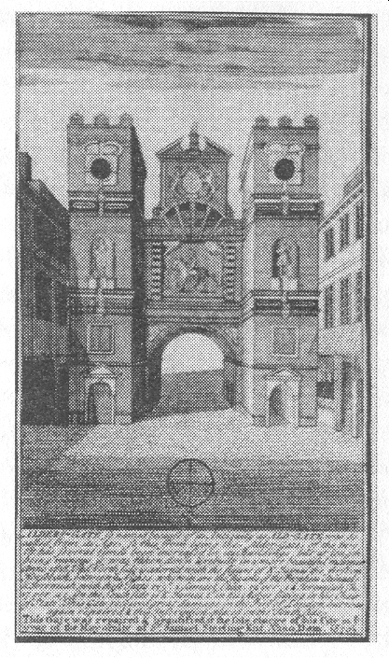
Aldersgate in around 1700
The choice of Jeremiah as the second prophet may have been connected with the belief that he was to be identified with Olam Fola, the ancient who is said to have brought the Lia-Fail to Ireland. However, the principal reason why a statue of Jeremiah of all people was placed on a gateway to London is indicated by the text of the inscription that was put up below his statue (Jer. 17: 25). This read: 'Then shall enter into the gates of this city, kings and princes, sitting upon the throne of David, riding in chariots and horse. And this city shall stand for ever.'
Aldersgate was immediately to the north of St Paul's Cathedral, on the old Roman road of Watling Street, which ran from the Kent coast, via Canterbury, London and St Albans, all the way to north Wales. Jeremiah was, therefore, presiding over the principal gate on the principal highway of the kingdom. On the north side of the gate King James is shown riding his horse and it is likely, though this is difficult to confirm, that it was through this very gateway that James arrived in London after being proclaimed king in succession to Elizabeth; this might be an explanation for the reference to kings and princes on horseback arriving by this gate. Similarly, on the inner, southern side of the gate he is shown sitting on his throne. This is clearly intended to symbolize him sitting on the 'throne of David', which could obviously be an allusion to the way that he, as James VI of Scotland, sat on the throne once occupied by David I of Scotland. However, as so often, there does seem to have been a further, deeper meaning to these symbolic representations. The passage from which the inscription is taken offers further illumination. It begins and ends as follows:

Then said the Lord to me: 'Go and stand in the Benjamin Gate, by which the kings of Judah enter and by which they go out, and in all the gates of Jerusalem, and say: "Hear the word of the Lord, you kings of Judah, and all the inhabitants of Jerusalem, who enter by these gates. Thus says the Lord: Take heed for the sake of your lives, and do not bear a burden on the Sabbath day or bring it in by the gates of Jerusalem. . .

, ". . . But if you do not listen to me, to keep the Sabbath day holy, and not to bear a burden and enter by the gates of Jerusalem on the Sabbath day, then I will kindle a fire in its gates, and it shall devour the palaces of Jerusalem and shall not be quenched.'" (Jer. 17: 19-27)

In ancient Israel the tribe of Benjamin had its territories immediately to the north of Jerusalem. Actually, technically speaking, Jerusalem was within the tribal estates of Benjamin, though it was on the border with Judah, only five miles from Bethlehem. Thus, like Aldersgate in London, the Benjamin Gate of Jerusalem would have been on the north side of the city. By placing Jeremiah's statue and the quote from this chapter at Aldersgate, James seems to have been hinting at secret knowledge concerning both himself as David's heir and. London's identity as the capital of Israel; a 'New Jerusalem', so to speak.
It was undoubtedly the conviction that he was God's anointed sitting on the throne of the biblical David that lay at the root of James's belief in his divine right to govern. Just as the Tudors had made use of Welsh legends concerning King Arthur and his Round Table in the development of their programme for building a British empire, so James Stuart brought with him from Scotland ideas and people that were to have a profound effect on the development of English thinking in the seventeenth century. The most important of these was Scottish Rite Freemasonry, whose origins are shrouded in mystery.

